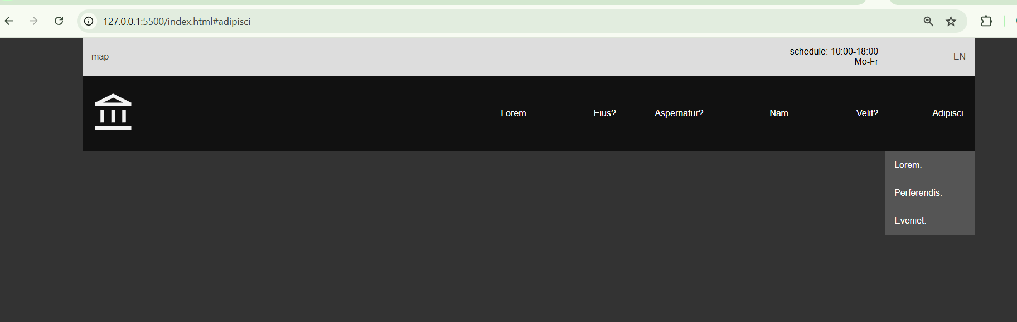  
  
https://github.com/CristinaBors/HW_UX_UI/tree/main/Lesson%2034/Navbar-CSS-Grid